**APPAREL WEBSITE**

The websites where users can buy the new stylish clothes and people can shop according to categories requirements

Navigation bar (on top)



* Company name
* Search bar
* Location selection
* Cart

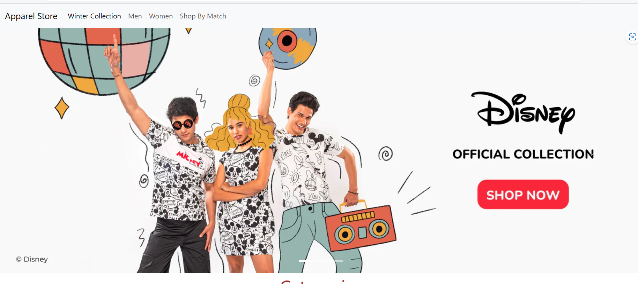

Menu bar

* A horizontal division below navigation bar where different categories of items are available to see.

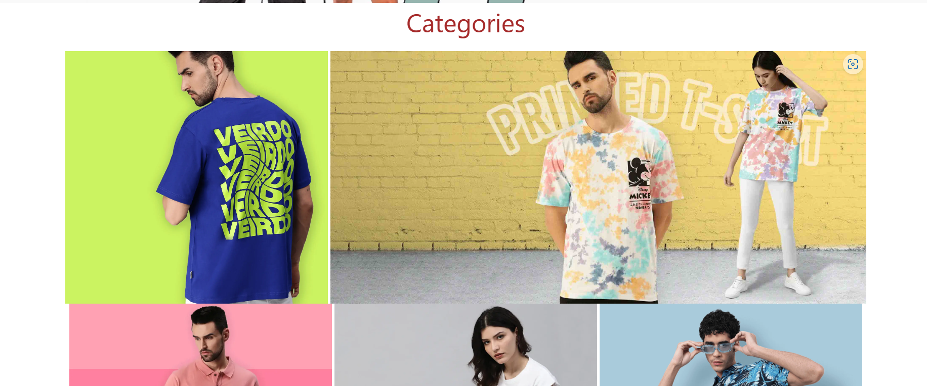

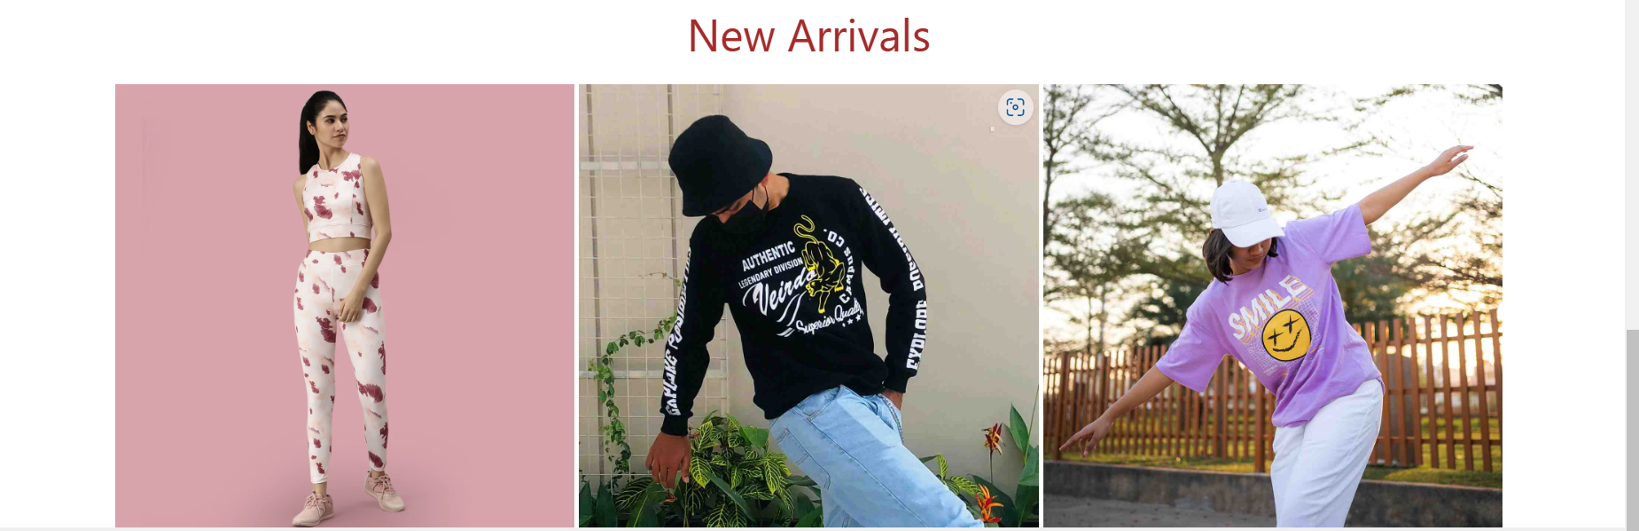

Filters

* Sort by price
* User rating
* Price ranges
* Popular brands
* discount

Item’s list

* Each item in separate division.
* Image of item and name
* Option to buy and add to cart
* Increase the quantity of item
* User rating
* Discount offers if available